December 2, 2005

Dear Yule Cup Participants,

Joyce and Laurie would like to thank everyone for the wonderful response to our pre-registration. Again, the response has been wonderful. We really appreciate being included in your competition season.

Registration papers are included in this packet, and we would like to ask that you do not register more gymnasts than what you pre-registered for. These papers are due by December 20, 2005, with full payment.

This is the 22nd year that Yule Cup will have been held. It started as a small add-on to a local state competition and has grown to a large, enjoyable competition.

We will be advising you on the schedule soon. NOTE! Please make your travel plans to leave on Monday morning as we will end late on Sunday and Monday is a holiday. The meet schedule will not be changed because of plane reservations.

A couple of other notes…
- Music on CD’s-please have only one track per CD. We will not accept any multi-track CD’s. Also please make sure they are labeled correctly and are in good condition.

- If using tapes, please remember to cue them.

- Remember to subtract your registration fee from your total fees due. If you have already paid in full, please note that on your paperwork as a reminder to us.

- Pre-pay for Yule Cup teams is preferable, but you can pay at the meet. Turn in forms if teams are known, otherwise turn them in according to the technical sheet. This is for Yule Cup teams only, not individual registrations.

- NEW this year…JR’s and SR’s will be broken into Level 9 JR, Level 10 JR, Level 9 SR, and Level 10 SR. Please note that level 10 is for a gymnast who has competed at her National competition.

- All routines will need FIG script. All FIG technical and artistic forms-one (1) copy of each-need to be mailed to Laurie (address enclosed) no later than January 13, 2005 by 8pm. Forms will be accepted through the mail only-NO FAXES!! Please make sure you mail appropriately for time. Forms will not be taken on the day of competition. If you need copies of these forms, they are available on the USAG website (see enclosed web address) under rhythmic program, under rules and policies.

- All lower level international gymnasts will be included in either US Level 7 or Level 8. Please see the attached requirements. They will only be judged in matching USAG apparatus. They must perform all the US apparatus to be eligible for AA awards. They will be eligible for individual apparatus awards.

Practice on Friday night may be available depending on help with carpets and such. This will be
known closer to meet time and be included in the final mailing. Any help will be gratefully appreciated.

Please note that the entry deadline is December 20, 2005. Please make checks payable to Yule Cup. Again, we would like to say thank you for coming and see you soon.
Joyce Chaplin Laurie Frank
Region II Chairperson Co-meet Director
Meet Director Executive Assistant, Region II
2006 YULE CUP
22nd Annual Rhythmic Gymnastics Invitational
TECHNICAL INFORMATION

WHEN: Saturday, January 14, 2006
Sunday, January 15, 2006

WHERE: North Seattle Community College $5.00 admission
9600 College Way North $5.00 program
Seattle, WA 98103

SeaTac, Seattle, Washington is the closest airport, about 45 minutes to hotel and gym
Traditionally Yule Cup ends late on Sunday.
Please make your airline registrations for leaving Seattle on Monday.
Schedules will not be changed to accommodate airline schedules.
IMPORTANT!!!
ALL COMPETITORS/JUDGES/COACHES MUST HAVE A USAG NUMBER!!!
YOU WILL NOT BE ALLOWED ON THE FLOOR WITHOUT ONE.
TO APPLY, PLEASE GO TO THE USAG WEBSIGHT (www.usa-gymnastics.org/forms) AND
FAX THE DOWNLOADED FORM TO USAG AT 1-317-692-5212.
THE COST FOR A FOREIGN COMPETITOR/JUDGE/COACH IS $25.00US.

HOTELS: Hotels are approx. 10 minutes away from the gym.
Holiday Inn Express
14115 Aurora Ave. N
Seattle, WA 98133
Ph: 206-365-7777
Fax: 206-365-8888
$79.00 + tax 4 people/room
Indoor pool, Jacuzzi, sauna, complimentary deluxe continental Breakfast
Restaurants are nearby.

WHEN CALLING ABOUT THESE HOTELS,
PLEASE QUOTE “YULE CUP CHALLENGE”
TO MAKE YOUR RESERVATIONS BY JANUARY 6, 2006
Airporter Shuttle: www.airporter.com, 1-800-423-4219 (Cost usually $30-$40)
Other shuttle services available at the airport, along with rental vehicles

FEES: Payment MUST be postmarked by December 20, 2005
Checks made out to Yule Cup
Level 9/10/Junior/Senior $100.00
Level 7 & 8 $90.00
Yule Cup Team Fee $10.00 per team

EVENTS:
Level 9 & 10 SENIOR Rope, Ball, Clubs, Ribbon
Level 9 & 10 JUNIOR/CHILD Rope, Hoop, Clubs, Ribbon
Level 7 all divisions RFX, Rope, Hoop, Ribbon
Level 8 all divisions RFX, Rope, Ball, Clubs
**Please see attached form for requirements for Levels 7 & 8

AWARDS: All ties will be broken in this competition, for all levels.

YULE CUP TEAMS NOW NOT LIMITED TO ONLY ONE PER CLUB.
SMALL CLUBS MAY COMBINE TO MAKE A YULE CUP TEAM.

LEVELS 9JR, 10JR, 9SR, 10SR
YULE CUP: Awarded to a team consisting of A MAXIMUM OF 3 GYMNASTS, A MINIMUM OF 2
2 Senior Cups GYMNASTS. Gymnasts must be pre-designated before the meet. The cup will be awarded
2 Junior Cups to the team with the highest all-around score of 2 out of the three designated gymnasts of the team. Gymnasts will still be eligible for individual awards. There is a $10.00 fee per team to compete for the Yule Cup.

TERI BRUCE An award chosen by the judges. This is awarded to the gymnast who excels in her dance
DANCE AWARD skills, no age grouping.

INDIVIDAUL Medals will be awarded to 1st, 2nd, and 3rd places in the above mentioned age divisions.
ALL AROUND Rosettes will be awarded to 4th through 10th places, same division breaks.
AWARDS

APPARATUS Ribbons will be awarded for 1st thru 8th place for each apparatus, in the above mentioned
AWARDS age divisions.

PICTURE Pictures are awarded to the 1st aa winners in the JR and SR levels only. 4 Pictures total
AWARDS

LEVELS 7 & 8
Lower level international gymnasts will be included in US Level 7 & 8
Please see attached requirements
JR. YULE CUP There will be a cup awarded for both levels. Same team designations and rules as
1 cup for described above apply. There is a $10.00 fee per team to compete for this award
each level

INDIVIDUAL Medals will be awarded to the 1st, 2nd, and 3rd places in all divisions; child A, child B,
ALL AROUND junior, and senior. Rosettes will be awarded to 4th through 10th places, same division
AWARDS breaks.

APPARATUS Ribbons will be awarded for 1st through 8th places for each apparatus, in each division,
AWARDS child A, child B, junior, senior.

PAYMENT DUE DATE FOR PAYMENT AND COMPLETED ENTRY FORMS
DECEMBER 20, 2006
MAKE CHECKS PAYABLE TO YULE CUP
CONTACTS:
Laurie Frank Joyce Chaplin
1804 74th ST SE 1980 E. Cattail Ln.
Everett, WA 98203 Freeland, WA 98249
Ph: (425)337-7075 Ph: (425)745-0951
Cell: (425)-345-7075 Cell: (425)238-2079
Fax: (425)438-9003 Fax: (360)321-7085
e-mail: frank1804@aol.com e-mail: engflowr@whidbey.com

USAG Level 7 & 8

Music length: 1:15-1:30

Level 7
Floor Routine (RFX) Max score 10.0
Difficulties | Artistry | Execution
Skills = A, B, C, D, E, | Basic Composition = 1.5 | Max = 5.0
# of skills = 10 | Music = 0.5
Equal distribution of body groups

Level 8
Floor Routine (RFX) Max score 12.0
Difficulties | Artistry | Execution
Skills = A, B, C, D, E, F | Basic Composition = 1.5 | Max = 5.0
# of skills = 12 | Music = 0.5
Equal distribution of body groups

**Equal distribution of body skills are required. No more than 2 between differences in body skills.
Ex. 12 skills = 3,3,3,3 or 3, 4, 3, 2

Apparatus Routines
 | D(TV)-Max Value | TV - # of Difficulties | TV – Allowed  Value | Min-Comp Body Group | Max – Other Body Group | AV-Basic Comp | AV-Music | AV-Max Value CAP | Execution | Max Total Score
Level 7 | 3.00 | 10 | A,B,C,D,E, | 5 | 2 from each | 2.00 | 1.00 | 2.00 max | 10.00 | 14.00
Level 8 | 5.00 | 12 | A,B,C,D,E,F | 6 | 2 from each | 2.00 | 1.00 | 4.00 max | 10.00 | 16.00

Skills Level 7: RFX, Rope, Hoop Ribbon.

Skills Level 8: RFX, Rope, Ball, Clubs

Age divisions-depends on birthdate by Dec. 31, 2005
Child ages 6-11
Can be broken up into Child A, Child B, etc. Requirements don’t change, just what group they are
placed in.
Junior ages 12-15
Senior 16-up

Competition Entry Form

Event |  | 2006 Yule Cup |  |  |  |  |  |  |  |  |  |  |  |  |  | Date
Team Name
Name of Club |  |  |  |  |  |  |  |  |  |  |  | Head Coach
Mailing Address
City |  |  |  |  |  |  |  |  | State |  |  | Zip |  |  |  |  | Phone
Email:

LIST ALL COACHES ATTENDING COMPETITION:
Name | USAG Pro Membership No. | Safety Certification Expiration Date (required for State and above)

Signature of Head Coach |  |  | Date

Yule Cup Teams |  |  |  | Level 7 @ |  | $90.00 | = | $
Level 7 @ $10/team |  |  |  | Level 8 @ |  | $90.00 | = | $
Level 8 @ $10/team |  |  |  | Level 9/10 @ |  | $100.00 | = | $
Level 9/10 JR @ $10/team
Level 9/10 SR @ $10/team |  |  |  | Yule Cup Teams |  | $10/team | = | $
Total Yule Cup Teams Cost |  |  |  | Less Deposit |  |  |  | -$
Please transfer the total fees to the box on the right |  |  |  | TOTAL FEE ENCLOSED |  |  | = | $
 |  |  |  | CHECK #

This Entry Form will not be accepted if postmarked after: | December 20, 2005

Return this cover sheet along with all appropriate Level entry forms to:
Laurie Frank Or email all forms to:
1804 74th St SE Frank1804@aol.com
Everett, WA 98203

Athletes with medical reasons validated by a physician may request a 50% refund.
(Written request must be received within 3 business days of the meet.)
Age Group Descriptions:
Children’s Division A - ages 6-8 - a gymnast MUST compete at age 5 in the Children's Division A if she will turn 6 by December 31.

Children's Division B - ages 9-11 a gymnast MUST compete at age 8 in the Children's Division B if she will turn 9 by December 31.

Junior’s Division ages 12-15 - a gymnast MUST compete at age 11 in the Junior Division if she will turn 12 by December 31

Senior’s Division ages 16 and over - a gymnast MUST compete at age 15 in the Senior Division if she will turn 16 by December 31

Level 7, 8, Novice Entry Form

Name | Birthdate  (mm/dd/yy) | Age Group  (CHA,CHB, JR, SR) | USAG # | RFX  Or  Free  L7 & 8 | Rope  L7 & 8 | Hoop  L7 | Ball  L8 | Clubs  L8 | Ribbon  L7

L9JR, L10JR, L9SR, L10SR Entry Form

Name | Level  9 or 10 | Age  Group  (JR, SR) | Birthdate  (mm/dd/yy) | USAG #

Yule Cup Teams 2006

Please use this form to indicate who your Yule Cup Team(s) will be. These teams need to be designated by the start of competition on Saturday and paid for by that time ($10.00 per team). The names will be kept in conficence and it will be up to the coaches to let the girls know if they are a Yule Cup team or not. If you have more than one team per level, please write them to the side and indicate their level.

A Yule Cup team consists of 2-3 gymnasts. The team score is determined by the top two AA scores added together.

Club: ______________________________________________________________________________________

Coach: _____________________________________________________________________________________

Level 7 Team:
_ ______________________________________________________
_ ______________________________________________________
_ ______________________________________________________

Level 8 Team
_ ______________________________________________________
_ ______________________________________________________
_ ______________________________________________________

Level 9 Junior Team
_ ______________________________________________________
_ ______________________________________________________
_ ______________________________________________________

Level 9 Senior Team
_ ______________________________________________________
_ ______________________________________________________
_ ______________________________________________________

Level 10 Junior Team
_ ______________________________________________________
_ ______________________________________________________
_ ______________________________________________________

Level 10 Senior Team
_ ______________________________________________________
_ ______________________________________________________
_ ______________________________________________________

Directions

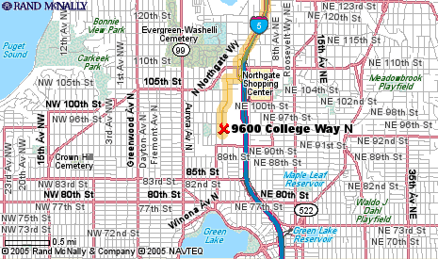
From the southbound I-5, close-up
Going from I-5 Southbound…
- Take Exit #173 Northgate Way/1st Ave NE
- Take Northgate Way WEST exit---go right at end of exit
- Follow to Meridian Ave (next traffic light) and turn LEFT
- Follow Meridian about ½ mile---NSCC is on the left
- Take first entrance, follow road through parking lot to Wellness Center (building with red pipes on roof)

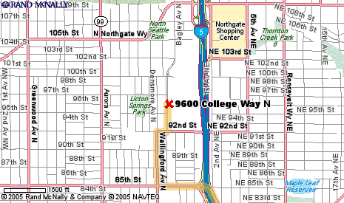
From northbound I-5, close up

Going from I-5 Northbound…
- Take Exit #172 85th St
- Turn RIGHT onto Wallingford Av, N
- Turn RIGHT onto 92nd St
- Bear Left onto College Way North
- Take first entrance to NSCC parking lot. Go through parking lot to Wellness Center (building with red pipes on roof)

Directions, con’t.

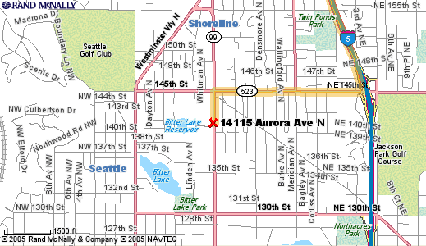

Map works for both ways
From Airport to Hotel…(from the South)
- From Parking Garage, follow signs to North I-5
- Follow I-5 North for approximately 21 miles, going past downtown Seattle
- Take exit #175 , N.E. 145th St and turn LEFT at traffic lights onto N.E. 145th St going west
- Continue on 145th St to Aurora Ave N.
- Turn left, (South) on Aurora Ave N , two blocks down is Holiday Inn on your right.

From the North to Hotel…
1) Take I-5 South and take exit #175, 145th St and turn RIGHT at end of off ramp
2) Continue on 145th St. to Aurora Ave N. and turn LEFT on Aurora Ave N.
3) Two blocks down is Holiday Inn on your right

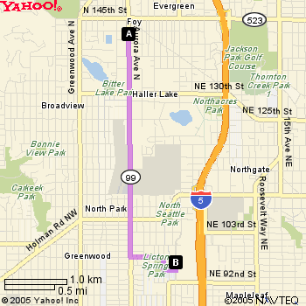
Map from Hotel to venue

From Hotel to Venue
- Turn RIGHT onto Aurora from Hotel parking lot
- Going South, go to 105th St. N (Should be a sign for North Seattle Community College
- Turn LEFT onto 105th and follow to Meridian Ave
- Turn RIGHT on Meridian (south) and NSCC will be on your LEFT
- Take first entrance and follow road to Wellness Center (building with red pipes on roof)

